**IPL Project – Problem Statement**

In this project, you have to perform the job of a sports analyst. You are given two datasets related to IPL (Indian Premier League) cricket matches. One dataset contains ball-by-ball data and the other contains match-wise data. You have to import the datasets into an SQL database and perform the tasks given in this assignment to find important insights from this dataset.

**About the Data**

The first CSV file is for ball-by-ball data and it has information of all the 193468 balls bowled between the years 2008 and 2020. It has 17 columns and below is the details of those 17 columns:

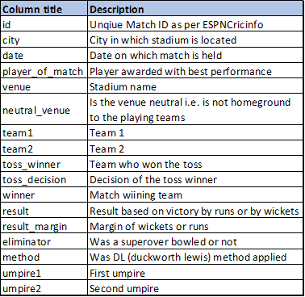

The second file contains match-wise data and has data of 816 IPL matches. This table has 17 columns and below is a short description of the columns in this table:



**Write queries for the following tasks:**

1. Create a table named ‘matches’ with appropriate data types for columns

2. Create a table named ‘deliveries’ with appropriate data types for columns

3. Import data from csv file ’IPL_matches.csv’ attached in resources to ‘matches’

4. Import data from csv file ’IPL_Ball.csv’ attached in resources to ‘deliveries’

5. Select the top 20 rows of the deliveries table